On the spaces provided beside the item, match the numbered element.

and circle the name of the wood frame type

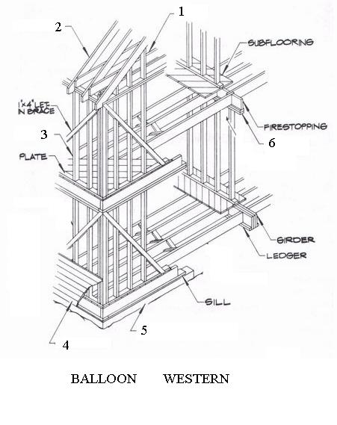

___Foundation Wall

___ Joist

___ Sheathing

___ Stud

___ Double Plate

___ Concrete Block (CMU)

___ Rafter

___ Bond Beam Bars

___ Vertical and Horizontal Rebars

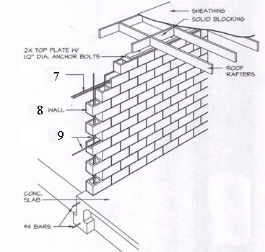

Identify the detail component

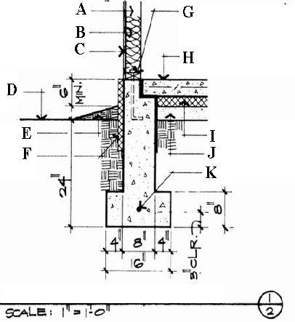

A________________________

B________________________

C________________________

D________________________

E________________________

F________________________

G________________________

H________________________

I________________________

J________________________

K________________________

Identify the detail component

A________________________

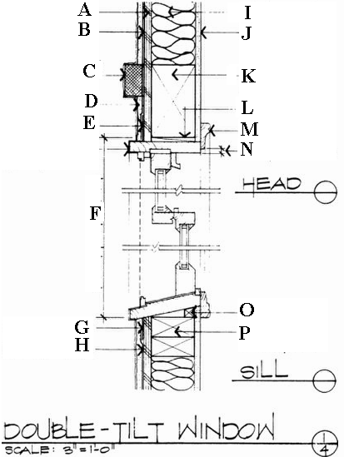

B________________________

C________________________

D________________________

E________________________

F________________________

G________________________

H________________________

I________________________

J________________________

K________________________

L________________________

M________________________

N________________________

O________________________

P________________________

Identify the detail component

A________________________

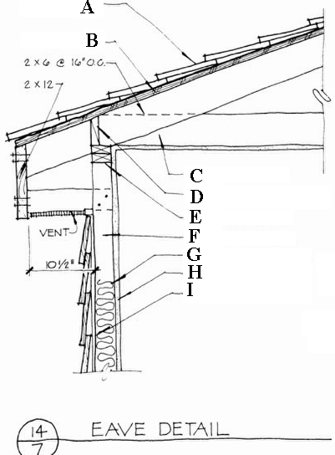

B________________________

C________________________

D________________________

E________________________

F________________________

G________________________

H________________________

I________________________